
PROJECT 4
Project Proposal
Term 2 Assignment

Group Number: 7

Group Name: The Legendaries

Members:
No. | Surname, Initial | Student Number
1 | Kabai Moipone | 2 | 1 | 5 | 2 | 0 | 3 | 5 | 6 | 9
2 | Mkalali Siphelele | 2 | 2 | 0 | 0 | 4 | 2 | 9 | 2 | 6
3 | Msomi Sebe | 2 | 1 | 6 | 0 | 2 | 8 | 6 | 0 | 4
4 | Ncubukezi Bongeka | 2 | 1 | 5 | 1 | 8 | 0 | 9 | 2 | 5
5 | Tshizana Busiswa | 2 | 0 | 9 | 0 | 5 | 7 | 1 | 8 | 1

Due Date: 22 July 2020

Table of Contents

Key words page 3
Introduction page 3
Background and Statement Problem page 4
How does social media contribute to the rise of fake news? page 4
Why are we doing this project? page 4
Figure1 page 5
Detailing page 5-7
Strengths of the application when it succeeds page 6
Weakness of application page 6
Risk Identification page 6
Risk Prevention page 7
Summary of the Application page 7

Keywords
Fake news, social media, Web application, Covid-19, Fact checking
Introduction
Many people now get news from social media sites and network of which it can be difficult to tell whether stories are credible or not especially when fake news gets more attention than real news. Social media is an interactive computer-mediated technology that facilitates the creation and sharing of information, ideas, career interests and other forms of expression via virtual communities and networks. Daily or at least most of the time we use social media to acquire information. Examples of social media platforms include. Facebook, YouTube, Twitter, LinkedIn, Instagram and many more
In the process of using these social media platforms, we often lose focus on why we chose to use them in the first place. This is usually caused by the need for popularity which influences so many things, like the content shared amongst these platforms. Sensibly, people use social media to network and stay in touch with others, to stay updated with news and current events, for entertainment and many more. Most of the information consumed from the media is secondary, meaning that it is not the true version of the story, or at least what we believe to be factual.
Our aim is to try decrease this terrific rise of these deceptive news by developing a mobile application that will be user-friendly and not require any kind of training before the end-user could interact with it. Our application will have a search box where any title of an article, blog, or journal could be typed in for searching the probability of that information being true. For example, if a user types ‘Drug use in Cape Town and the author name’ and enters search, it should retrieve the article title, next to it the probability of it being false all in bold.

Background and Problem Statement
How does social media contribute to the rise of fake news?
We have come to the realization realized that fake news is excessively growing on social media platforms. Our aim is to thoroughly research this concept while outlining how these news are spread out and why so that we could try decrease this terrific rise of these deceptive news by developing a mobile application that will be user-friendly and not require any kind of training before the end-user could interact with it. The most obvious reasons for the spread of false news is that everyone feels entitled to sharing their opinions, being their own version of the story and that no one ever face legal actions for deformation.
Social media has allowed people the ability to exchange information at a much greater pace, to a far wider audience than ever before. However, this information is not always truthful. (Companies fear rise of fake news and social media rumours, 2020) states that fake news and false market rumours spread by social media are becoming an increasing headache for companies around the world, fresh data reveal. The deliberate making up of news stories to fool or entertain is nothing new. But the arrival of social media has meant real and fictional stories are now presented in such a similar way that it can sometimes be difficult to tell the two apart.
Why are we doing this project?
Fake news causes confusion about current issues and events, but it continues to be circulated. Based on the research topic, it is important for us to research how people encounter the spread of fake news with regards to Covid-19. This will help us in implementing a solution to limit the amount of false information spread on the media since most people do what is called ‘passive networking’ – that means users who come to social media to consume content rather than actively contributing to the stories. This will also help people to have the real information about matters around them. Because we live in a technology based world, everything travels quickly and fast in the social media platforms.
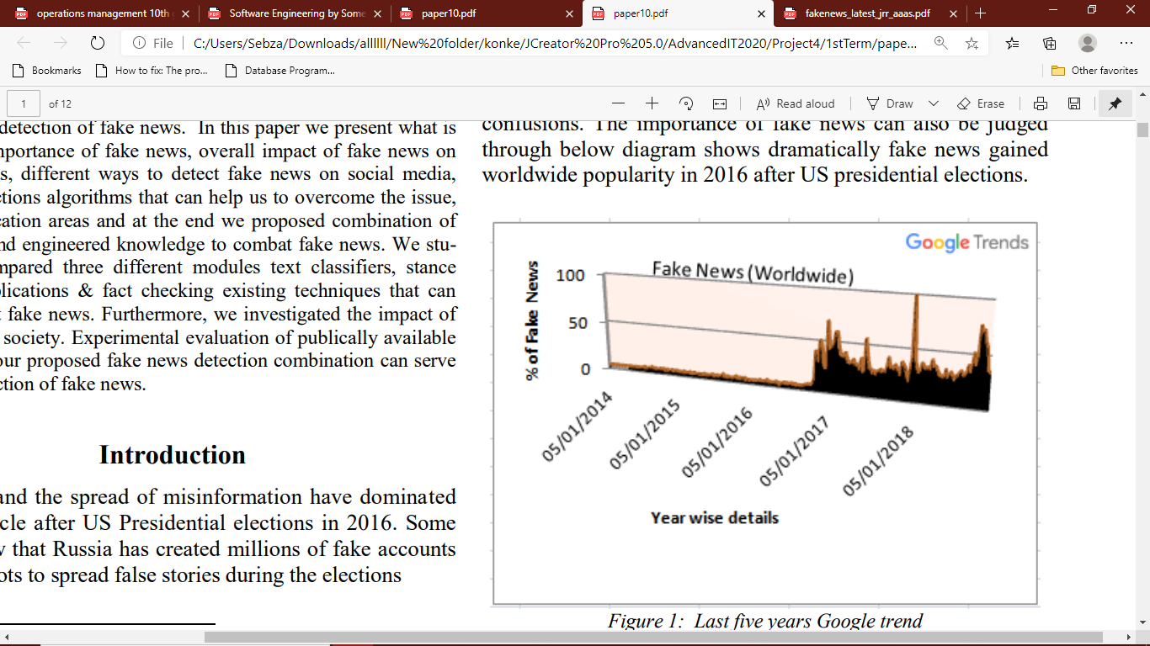
Figure1
Fake news changes the way people interpret and respond to real news. For example, some fake news was just created to trigger people’s distrust and make them confused, impeding their abilities to differentiate what is true and what is not true (Scott et al., 2000; Leonhard et al., 2017; Himma 2017). It is important to understand that fake and deceptive news have existed for a long time. It’s been part of the conversation as far as the birth of the free press (Soll 2016).
Detailing
We are assuming that at the end of the project we will have a fully functional web application. It may be a bit difficult to write test cases considering that we will be comparing real data that exists and fake news that are already considered factual by the society. To measure these outcomes, we will have a rating option on the application for the users where they will tell us whether our information is accurate or not. We will also measure using information stored on our database, meaning as soon as a user registers on our web application what they search will be stored under our search history to improve our fact checking system.

Strengths of the application when it succeeds
The software we are going to create will be compatible with any device for running the application to detect Covid-19 fake news .The main objective to be achieved is to create web application that distinguishes between fake news and real news using several algorithms. We will be using Fact-checking, Text-classification and Machine learning. Fact-checking will assess the authenticity of the news from the source or from the credibility of the news source. Text classification is classifying the authenticity of the news, it will be classifying either by headlines or link of the news; source. Machine learning, such as Artificial Intelligence will help us solve the complexity of the data to the real-world data. The main objective is to build an application to accurately classify a piece of news as real or fake. When the application is running, people will learn to distinguish between what is true and what is an attempt to deceive.
Weakness of application
Project boundaries is that our web application will only focus on detecting the credibility news articles therefore it will only accept links with information and read image authenticity. Normal post on social media platforms will be regarded as false information because there will be no credible source that will say where is true. People without devices will not be able to access our application and those without internet connection because our application requires internet connection to be able to connect to the database for retrieving accurate results. When we cannot get enough and sufficient resources, our project will result in poor quality than the expected one, but we will find ways to accommodate the deployment of our project.
Risk Identification
We will make sure no data is breached. If you build an app or software that collects user data, such as names, email addresses, dates of birth, or telephone numbers, then it is our responsibility to keep that data secure. That means complying with data protection laws.

Risk Prevention
We will make sure that everyone is on board with duties and everyone understand the tasks. Everyone will have a copy of the work and we will make use of cloud back up by using things such as GitHub or DevOps. We will check the operating systems of our devices. We will use data encryption to secure the data of users.
Summary of the Application
Our project is only limited in focusing on detecting the integrity of the news found in articles, journals, blogs or any other platform providing news, meaning it will only accept links with information. For example, if you paste a Facebook link, an error should pop up that tells you the application does not support the source of information you are trying to retrieve.

